Title: Fish assemblages in the Upper Mississippi backwaters shifted to backwater lake sport fishes over 30 years

Authors & Affiliations:

James Pierce±, Kristen Bouska², David Elzinga, Richard Erickson², Daniel Gibson-Reinemer², Danelle M. Larson^{2,} , Markus Mika, Gregory Sandland, David Schumann

²U.S. Geological Survey, Upper Midwest Environmental Sciences Center, 2630 Fanta Reed Road, La Crosse, WI 54603, USA

±Corresponding Author:
James Pierce, jpeirce@uwlax.edu

Journal Target:
Ecology and Freshwater Fish OR Environmental Biology of Fishes

Review Disclaimer:
This draft manuscript is distributed solely for purposes of scientific peer review. Its content is deliberate and pre-decisional, so it must not be disclosed or released by reviewers. Because the manuscript has not yet been approved for publication by the U.S. Geological Survey (USGS), it does not represent any official USGS finding or policy.

HIGHLIGHTS
- BULLET POINT 1
- BULLET POINT 2
- BULLET POINT 3

ACKNOWLEDGMENTS
We thank reviewers at the U.S. Geological Survey for improving the manuscript. Any use of trade, firm, or product names is for descriptive purposes only and does not imply endorsement by the U.S. Government.

STATEMENTS AND DECLARATIONS

Funding
The data collection and authors DL and KB were funded by the Upper Mississippi River Restoration Program. XXXXXXX.

Competing interests
The authors have no competing interests to declare.

Author contributions
DML contributed to Conceptualization, Data curation, Visualization, and Writing

Data availability
All data were publicly accessed on 1 November, 2025 through the Upper Mississippi River Restoration Program’s Long-term Resource Monitoring data hub (https://umesc.usgs.gov/ltrm-home.html). Data analysis scripts and our secondary datasets are publicly shared on GitHub (https://github.com/jppeirce/ltrm_fish).

Keywords: cluster analysis, fish community assembly, lentic fish habitat

ABSTRACT
We sought to understand lentic, backwater fish assemblages in the UMR in the autumn (prior to overwintering) to inform management and long-term monitoring.

INTRODUCTION rough outline (aim for <900 words)
- Biological community assemblages are structured by multiple spatial and temporal patterns and processes. An ‘assemblage’ is a collection of co-occurring species based on species composition, and each assemblage may form a relatively predictable group based on environmental features. Humans have increasingly reshaped biodiversity and biological assemblages globally in various ways. As examples, biotic homogenization occurred in European marine fishes due to warmer ocean temperatures (Magurran et al., 2015) and in South American riverine fishes due to non-native fish invasion (Petesse & Petrere, 2012), while freshwater fishes in the United States have diversified following a decline in an invasive competitor fish (Bouska, 2020). Fish assemblages are a result of regional processes like biogeography and dispersal abilities, followed by localized environmental filters like biotic interactions, inundation regime, and water quality. Strong river gradients of water depth, velocity, and water quality may produce distinct riverine fish assemblages that prefer or rely on such habitat characteristics.
- UMR is a unique ecosystem with international recognition as an important wetland ecosystem that supports an abundance of wildlife and fish, and presumably important fish assemblages. The UMR has lots of long-term data on fishes and habitat, and this long term data shows lentic habitats in the UMR have changed for various reasons; so have the fish assemblages changed as well?
- Clustering algorithms can define biological assemblages based on species composition to inform ecology and management. Recent UMR examples include clustering analyses to describe common floodplain forest tree assemblages important to forestry and floodplain ecology (Windmuller-Campione et al., 2022) and aquatic vegetation types important to managing wildlife habitat and achieving ecological restoration goals (Larson, Carhart, et al., 2023). Defining biological assemblages helps researchers to delve deeper into environmental drivers that are specific to each assemblage (Delaney & Larson, 2022), as well as support resource managers to articulate their management goals (e.g., which fish assemblage are we managing for?) and understand the habitat characteristics required to support various communities.
- We used clustering to identify the common fish assemblages in a ~400 km river stretch of the UMR in autumn, prior to the fish overwintering. We explored whether fish assemblage structure had changed over 35 years given the fishes had experienced significant environmental changes over this period. The spatial and temporal patterns discovered can help ecologists understand changes in relation to environmental drivers, as well as river managers articulate their fish management goals for target.

METHODS

Study area
The Upper Mississippi River (UMR) flows ∼2200 km through the United States, and its 29 navigation locks and dams have created large pools upriver from each navigation dam. Lock and dams were installed in the late 1930s and created new shallow habitats that support aquatic plants and a diverse community. We included 4 study areas across a ~400 river km stretch named Upper Pool 4, Lower Pool 4, Pool 8, and Pool 13 as part of the Long Term Resource Monitoring (LTRM) element of the Upper Mississippi River Restoration program. We included these four study areas because they support 89 fish species (Ickes et al., 2022), remain a high restoration priority for providing quality overwintering lentic fish habitat (McCain et al., 2018), and have tremendous LTRM data on fishes, aquatic plants, water quality, hydrology, geomorphology, and land uses (https://umesc.usgs.gov/ltrm-home.html). Further, the 14 most common lentic fishes are abundant and lentic fish biomass has increased over the past 35 years for reasons unknown (Ickes et al., 2022). These study areas had also undergone ecosystem regimes shifts of improved water quality and aquatic plant recovery (Larson, Bungula, et al., 2023; Larson, Carhart, et al., 2023), as well as a fish community shift away from invasive common carp Cyprinus carpio towards a more functionally-diverse fish community (Bouska, 2020).
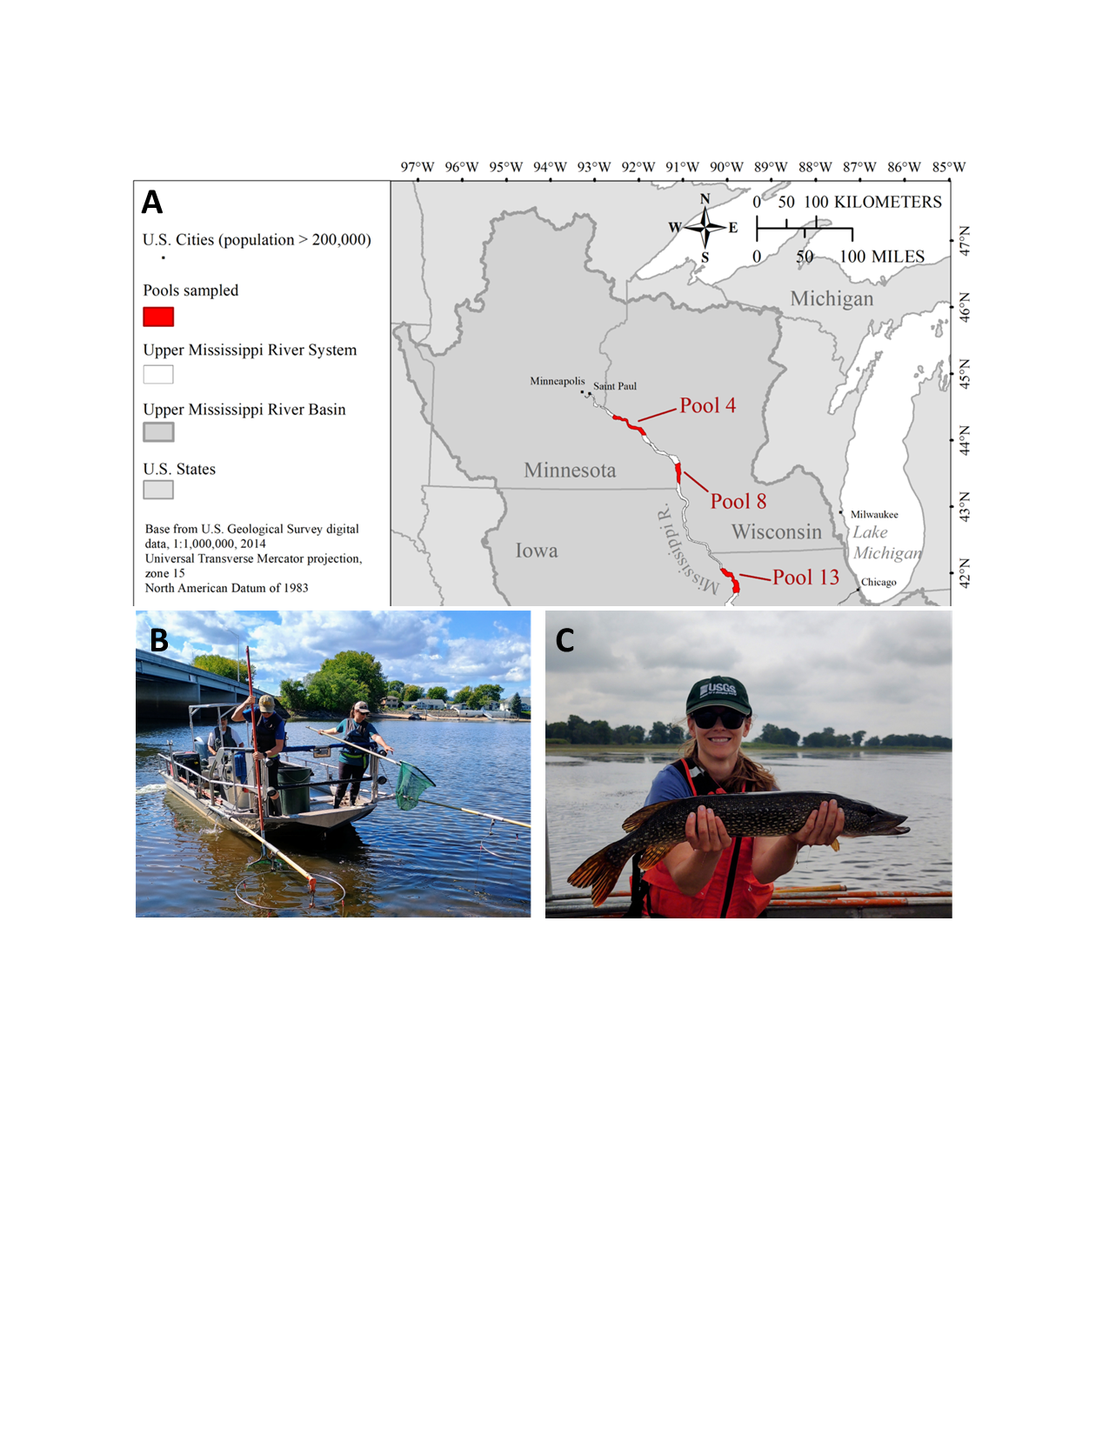
Figure 1. Map of the study areas (red areas in panel A) for fishes of the Upper Mississippi River, USA. Fishes were collected via daytime electrofishing (panel B) and were speciated and weighed individually (panel C). Map and pictures by author Danelle Larson, used with permission.

Data Collection and Processing
Our analyses fully relied on data collected by LTRM. Since 1993, fish experts funded by LTRM annually sample fish communities within the study areas using multiple gears within a stratified random sampling design as detailed in (Ratcliff et al., 2014). Given our interest in these LTRM study areas and their lentic fish communities, we subset the entire LTRM dataset to only include Pools 4, 8 and 13 within the backwater lake and impounded strata (codes: BWC-S and IMP-S) using daytime electrofishing gear (code: XXX). Before the electrofishing, several environmental variables were recorded, including Secchi depth (cm), water velocity (m/s), water temperature, (ºC), dissolved oxygen (mg/L), water depth (m), and percent vegetation coverage (%).Electrofishing systematically followed shorelines for 15 minutes and captured fish were cared for in tanks on the boat. Fish metrics for each captured fish species include presence and absence, relative abundance, and mass per unit effort. Live fish returned to the water as soon as processed.

Statistical Analyses

RESULTS

Clustering on the entire dataset revealed two major assemblages – lotic and lentic fishes

Lentic fish assemblage structure

Shifts in lentic fish assemblages over 35 years

DISCUSSION

Overview

Point 1

LITERATURE CITED
Bouska, K. (2020). Regime change in a large-floodplain river ecosystem: Patterns in body-size and functional biomass indicate a shift in fish communities. Biological Invasions, 22(11), 3371–3389. https://doi.org/10.1007/s10530-020-02330-5
Delaney, J. T., & Larson, D. M. (2022). Integrating machine learning and ecosystem state concepts: Modeling submersed plant resilience and vulnerability to ecosystem state transitions. In Review.
Ickes, B., Bowler, M., Bartels, A., & Maxon, K. (2022). Chapter G: Fisheries Indicators. In Ecological Status and Trends of the Upper Mississippi and Illinois Rivers (3rd ed., p. 218). U.S. Geological Survey.
Larson, D. M., Bungula, W., McKean, C., Stockdill, A., Lee, A., Miller, F. F., & Davis, K. (2023). Quantifying ecosystem states and state transitions of the Upper Mississippi River System using topological data analysis. PLoS Computational Biology, 19(6), e1011147. https://doi.org/10.1371/journal.pcbi.1011147
Larson, D. M., Carhart, A., & Lund, E. (2023). Aquatic vegetation types identified during early and late phases of vegetation recovery in the Upper Mississippi River. Ecosphere, 14, e4468. https://doi.org/10.1002/ecs2.4468
Magurran, A. E., Dornelas, M., Moyes, F., Gotelli, N. J., & McGill, B. (2015). Rapid biotic homogenization of marine fish assemblages. Nature Communications, 6(1), 8405. https://doi.org/10.1038/ncomms9405
McCain, K., Schmueker, S., & De Jager, N. (2018). Habitat Needs Assessment ‐ II : Linking Science to Management Perspectives. U.S. Army Corps of Engineers. https://doi.org/10.3133/ofr20181143
Petesse, M. L., & Petrere, M. (2012). Tendency towards homogenization in fish assemblages in the cascade reservoir system of the Tietê river basin, Brazil. Ecological Engineering, 48, 109–116. https://doi.org/10.1016/j.ecoleng.2011.06.033
Ratcliff, E. N., Gittinger, E. J., O’Hara, T. M., & Ickes, B. S. (2014). Long Term Resource Monitoring Program Procedures: Fish Monitoring (Upper Mississippi River Restoration-Environmental Management Program). U.S. Army Corps of Engineer.
Windmuller-Campione, M. A., Reuling, L. F., Van Appledorn, M., Nielsen, D. M., & Meier, A. R. (2022). What is a stand? Assessing the variability of composition and structure in floodplain forest ecosystems across spatial scales in the Upper Mississippi River. Forest Ecology and Management, 520, 120385. https://doi.org/10.1016/j.foreco.2022.120385

TABLES

FIGURES

Figure 1. Map of the study areas (red areas in panel A) for fishes of the Upper Mississippi River, USA. Fishes were collected via daytime electrofishing (panel B) and were speciated and weighed individually (panel C). Map and pictures by author Danelle Larson, used with permission.

SUPPLEMENTS
From Ickes 2022, Table G2. List of fish species selected for the lentic fishes indicator and their percentage contribution to total mass of lentic fishes sampled from all study reaches by daytime electrofishing from 1993 to 2019.
Common name | Scientific name | Total mass (percent)
Largemouth bass | Micropterus salmoides | 40.17
Bluegill | Lepomis macrochirus | 14.44
Bowfin | Amia calva | 14.22
Weed shiner | Notropis texanus | 7.04
Northern pike | Esox lucius | 5.82
Black crappie | Pomoxis nigromaculatus | 5.14
Longnose gar | Lepisosteus osseus | 4.29
White crappie | Pomoxis annularis | 3.07
Yellow perch | Perca flavescens | 2.63
Golden shiner | Notemigonus crysoleucas | 0.73
Spotted gar | Lepisosteus oculatus | 0.61
Green sunfish | Lepomis cyanellus | 0.43
Pumpkinseed | Lepomis gibbosus | 0.38
Orangespotted sunfish | Lepomis humilis | 0.19

